
Primorsko, Bulgaria!

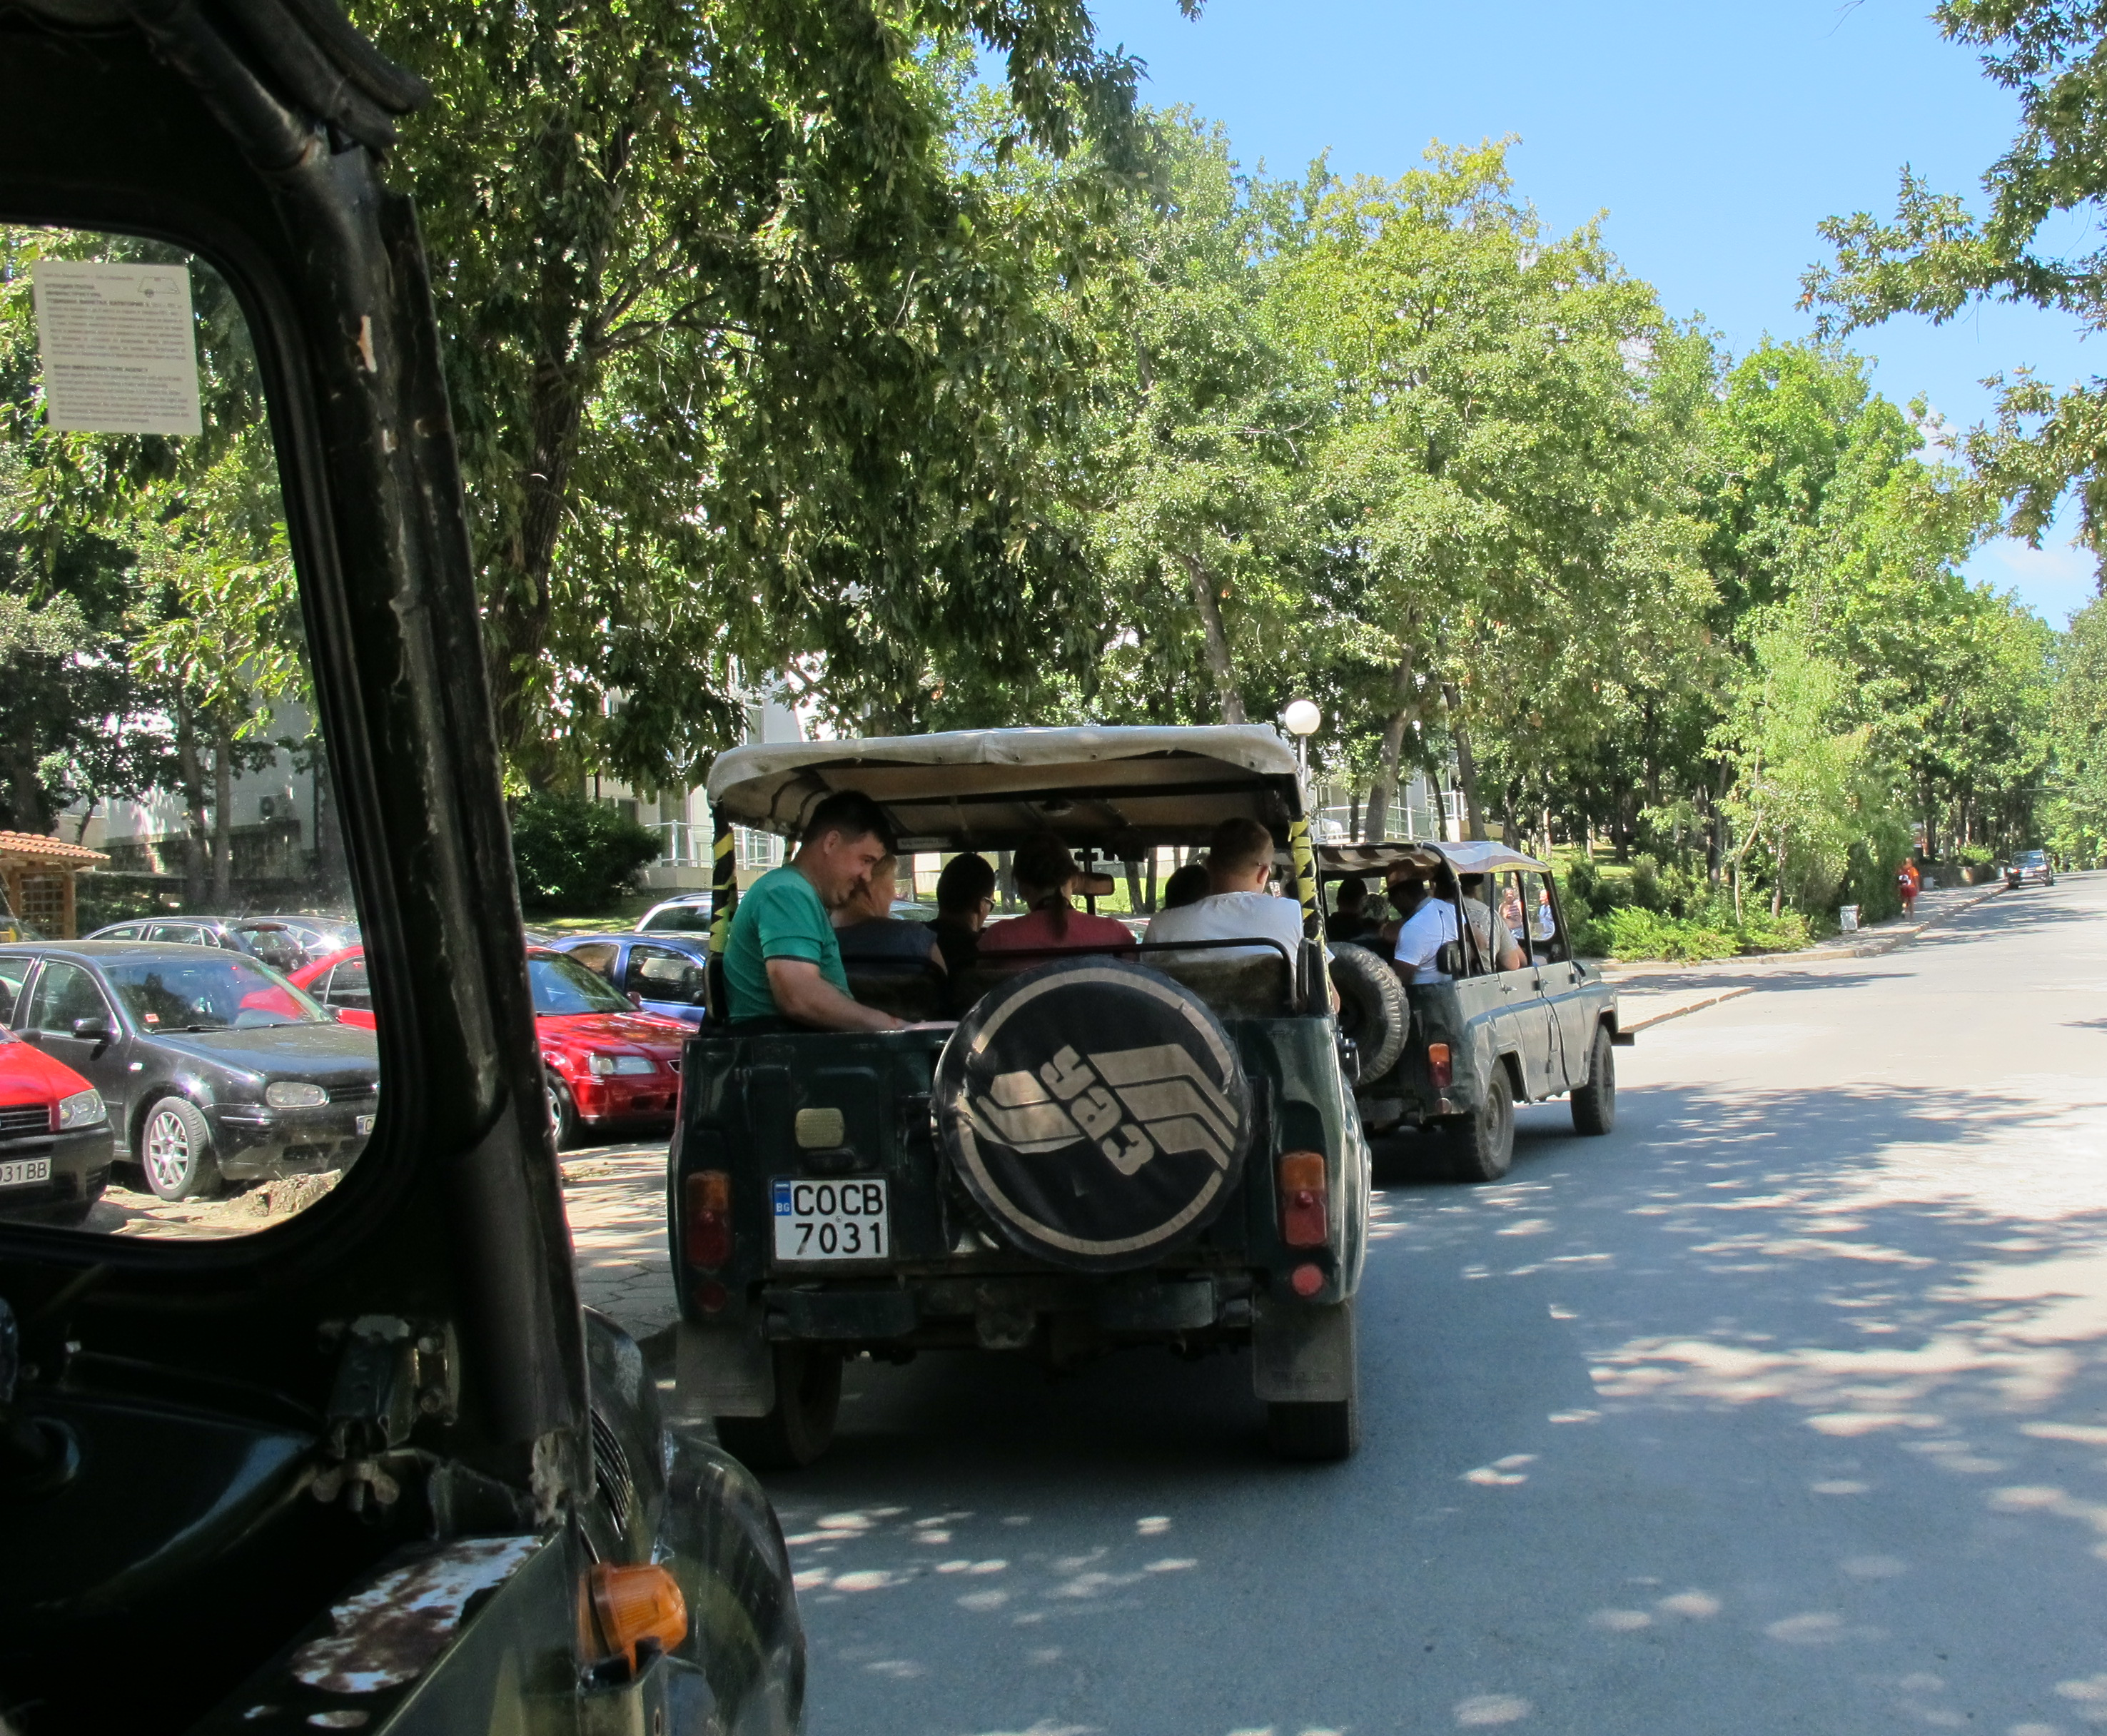
Join the MMI adventure at the Black Sea this summer!
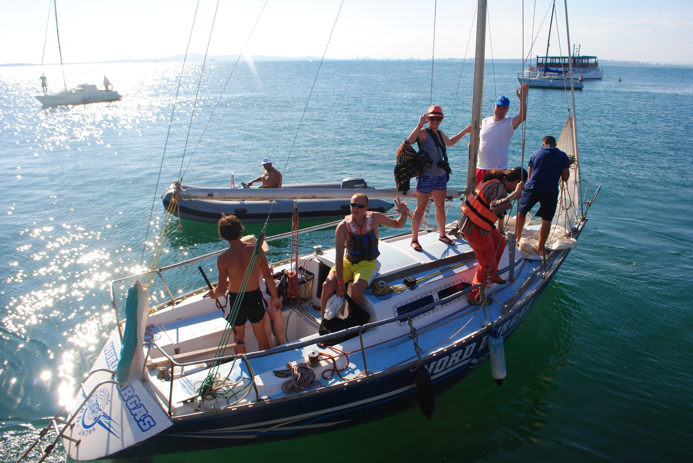
Do you like adventure? Would you like to enjoy the Black Sea Coast with good military Christian fellowship and friends from across Europe while taking part in:

Inspiring seminars,
Crazy dinghy runs, Swimming,
Horse riding,
Off-road jeep driving?

Inspiring Seminars: The morning sessions include practical Bible studies and teaching on:
- Practical Leadership
- Team work
- Effective communication
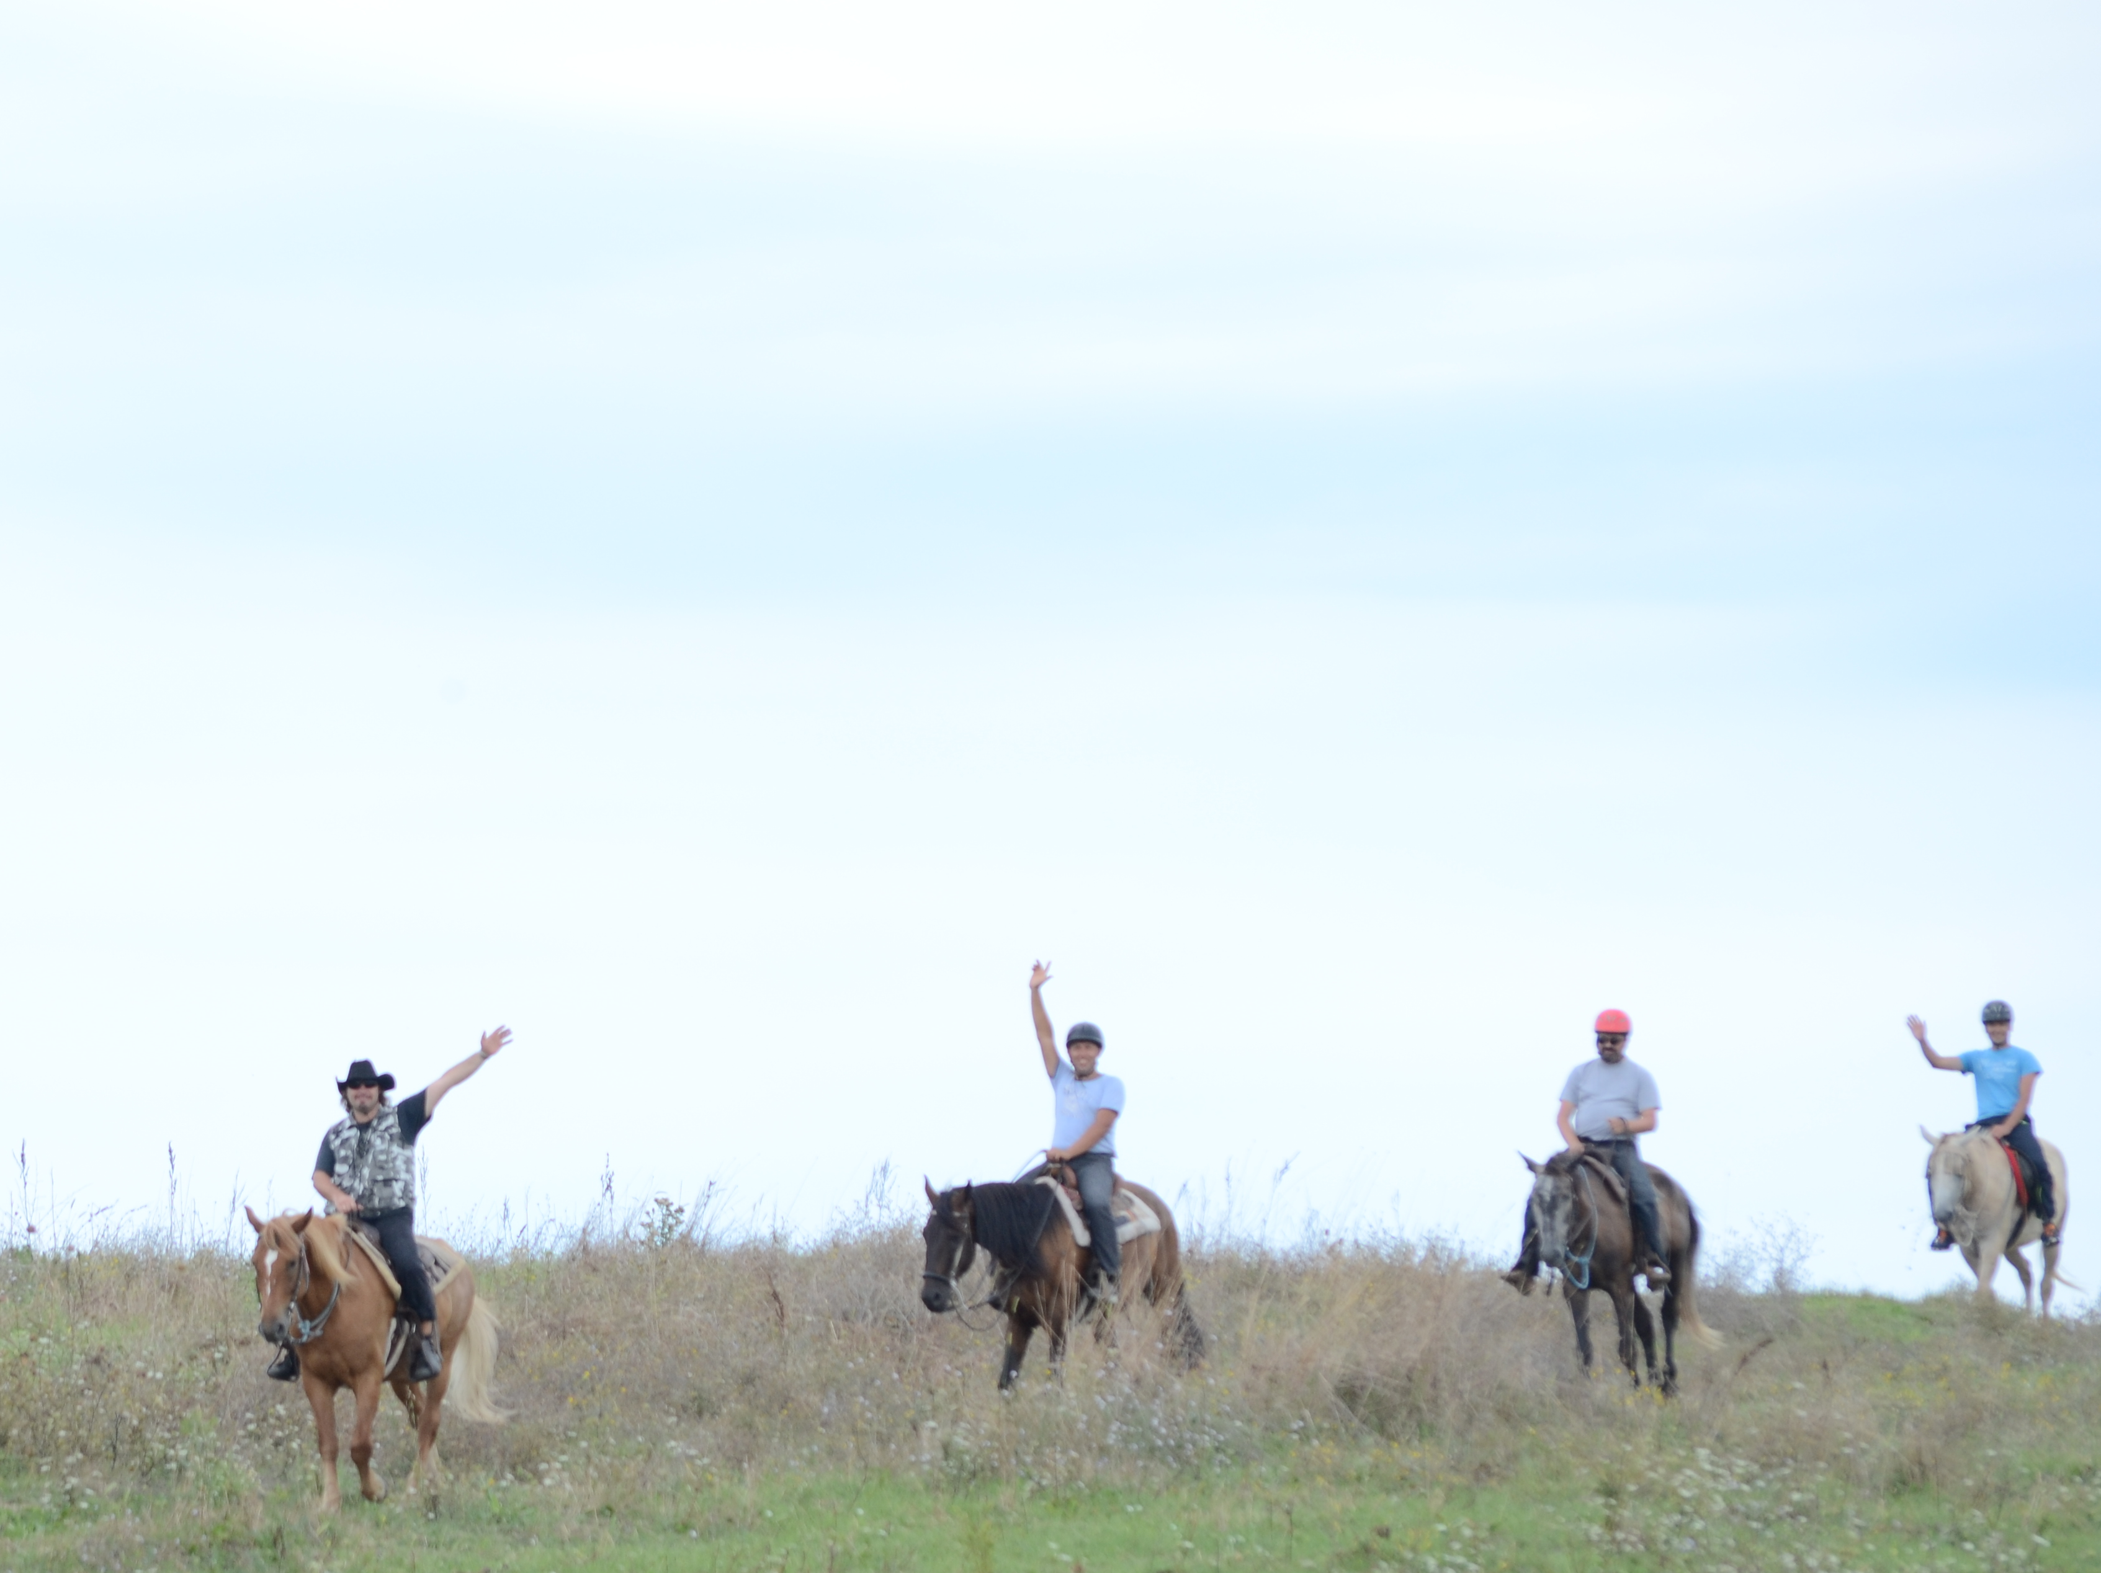
- Profession, Vocation, Calling in Life
- Christian faith and Military Service
- What the Bible teaches about War
- And more

Who is invited? MCF members, young officers or cadets who would like to grow in their spiritual development (leadership, character, team-building).
Couples are welcome too but child care will not be available.
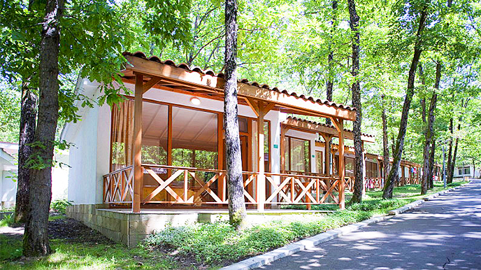

When and where is it? End of August
Primorsko Club, Holiday Villas, Bulgaria

How much would it cost me? – 180 EUR per person – includes in-country travel & full board for 5 days. Airfare, insurance and adventure activities are NOT included (average cost of adventures
= 50 EUR/person for the whole week)
There is limited scholarship availability with “early bird” registration.
How can I Register? Registration Form attached. For further information and payment methods, contact:
Rev Grozdan Stoevski (MMI Team Leader for Europe) e-mail: europe@mmi.org.uk ; mobile: + 359 896 685 672
OR Mark HH (MMI head office) email: headoffice@mmi.org.uk; Tel: +44 (0)1252 311222

Final DEADLINE for Registration is May,
However space is limited, book early to avoid disappointment! Don’t wait for the last moment!

We would be thrilled to have YOU join us!

www.mmi.org.uk

