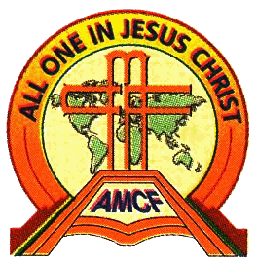
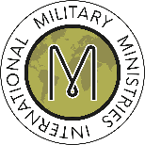

European Military Christian Meeting (EMCM)
Online by Zoom Saturday 24 April 2021
0900 – 1600 (UK)

Theme: Refreshment and Renewal.
3 short teaching sessions, each followed by break-out groups for further discussion and prayer on the theme.

For registration and more information, please contact:
europe@mmi.org.uk; or headoffice@mmi.org.uk

