MMI Prayer Day, Saturday 4th June, 2016

**More MMI information:**

comms@mmi.org.uk

or

01252-311222

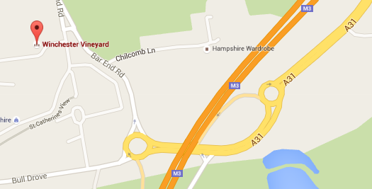

**Winchester Vineyard Church**

Unit 1, Bar End Industrial Estate, Bar End Rd, Winchester

SO23 9NP

Winchester Vineyard Church

[](http://www.google.co.uk/url?sa=i&rct=j&q=&esrc=s&source=images&cd=&cad=rja&uact=8&ved=0ahUKEwi6qbuZ7tLLAhVBApoKHR8sCq4QjRwIBw&url=http://www.examiner.com/article/when-the-door-opens&psig=AFQjCNFmSqMClp348M2rYepmXHwiw5Dmqg&ust=1458686570426941)

Pray

for

new

opportunities

**MMI**

**PRAYER DAY**

Saturday 4th June, 2016

09:30 to 16:00

Tea and coffee provided. Bring your own lunch